1. Serial

|  |
| --- |
| void setup() {  // Start the serial at a speed of 9800 baud  Serial.begin(9800);  }  void loop() {  Serial.println("Hello! What's your name?");    while (Serial.available() == 0 ) {} //Wait for reply  delay(100); // Ensure the whole message has arrived    Serial.print("Hello there ");  // Prints out input letter by letter  for (int i=Serial.available(); i>0; i-=1 )  {  char input = Serial.read();  Serial.print(input);  }  Serial.println("!");  } |

1. I2C

|  |
| --- |
| #include <Wire.h>  const int device_address = 0x4F;  void setup() {  Serial.begin(9600);  Wire.begin();  }  void loop()  {  // Ask the sensor for the temp (2 bytes)  Wire.requestFrom(device_address, 2);  // Turn two bytes into one value  word temp = (Wire.read() << 8) + Wire.read();  // remove unwanted data  temp = temp >> 5;  // Convert into degrees C and display Serial.println(temp * 0.125);  } |

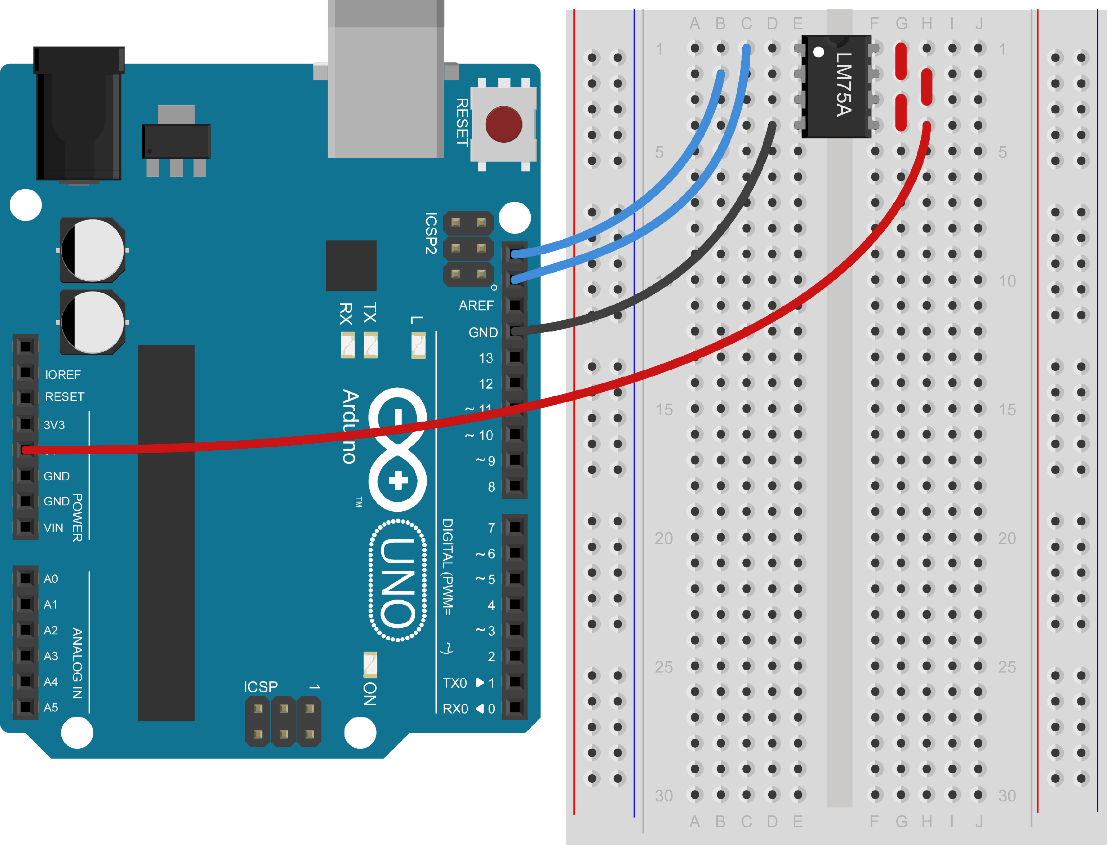

1. SPI

|  |
| --- |
| const int slaveSelectPin = 2;  const int clockPin = 8;  const int dataPin = 12;  void setup() {  pinMode(clockPin, OUTPUT);  pinMode(slaveSelectPin, OUTPUT);  pinMode(dataPin, INPUT);  Serial.begin(9600);  }  void loop() {  int data = 0;  // Start with clock low  digitalWrite(clockPin, LOW);  // Start transfer by setting CS=LOW  digitalWrite(slaveSelectPin, LOW);  // Read the next 12 bits  for (int i = 12; i>=0; i-=1) {  // Clock pulse  digitalWrite(clockPin, LOW);  digitalWrite(clockPin, HIGH);  // Read in value  data += (digitalRead(dataPin) << i);  }  // Finish transfer  digitalWrite(slaveSelectPin, HIGH);  Serial.println(data*0.0625);  } |

